**OVERVIEW**

**Submitted by,**

**Jithin K Narayanan**

|  |  |  |
| --- | --- | --- |
| **Sl.No** | **CONTENT** | **PAGE NO** |
| **1** | Program to Add two Numbers | **5** |
| **2** | Program to check Armstrong number | **6** |
| **3** | Find the number of elements in the array | **7** |
| **4** | To sort the elements in the array | **8** |
| **5** | To find the Fibonacci series | **9** |
| **6** | To split the array | **11** |
| **7** | Program to find the matrix multiplication | **12** |
| **8** | To find multiplication table of a number | **13** |
| **9** | To create simple login and logout | **14** |
| **10** | Simple registration form | **16** |
| **11** | Internspace | **19** |
| **12** | Abstract | **20** |
| **13** | Code | **21** |
| **14** | Screenshots | **49** |

**INDEX**

**Django**

Django is a Python-based free and open-source web framework that follows the model-view-controller (MVC) architectural pattern.[5][6] It is maintained by the Django Software Foundation (DSF), an American independent organization established as a 501(c)(3) non-profit.

Django's primary goal is to ease the creation of complex, database-driven websites. The framework emphasizes reusability and "pluggability" of components, less code, low coupling, rapid development, and the principle of don't repeat yourself.[7] Python is used throughout, even for settings files and data models. Django also provides an optional administrative create, read, update and delete interface that is generated dynamically through introspection and configured via admin models.

**Python**

Python is an interpreted, high-level, general-purpose programming language. Created by Guido van Rossum and first released in 1991, Python's design philosophy emphasizes code readability with its notable use of significant whitespace. Its language constructs and object-oriented approach aim to help programmers write clear, logical code for small and large-scale projects.Python is dynamically typed and garbage-collected. It supports multiple programming paradigms, including structured (particularly, procedural), object-oriented, and functional programming. Python is often described as a "batteries included" language due to its comprehensive standard library.

Python was conceived in the late 1980s as a successor to the ABC language. Python 2.0, released in 2000, introduced features like list comprehensions and a garbage collection system with reference counting.

Python 3.0, released in 2008, was a major revision of the language that is not completely backward-compatible, and much Python 2 code does not run unmodified on Python 3.

**SQLLite**

SQLLite is a relational database management system (RDBMS) contained in a C library. In contrast to many other database management systems, SQLite is not a client–server database engine. Rather, it is embedded into the end program.

SQLite is ACID-compliant and implements most of the SQL standard, generally following PostgreSQL syntax. However, SQLite uses a dynamically and weakly typed SQL syntax that does not guarantee the domain integrity.[7] This means that one can, for example, insert a string into a column defined as an integer. SQLite will attempt to convert data between formats where appropriate, the string "123" into an integer in this case, but does not guarantee such conversions and will store the data as-is if such a conversion is not possible.

SQLite is a popular choice as embedded database software for local/client storage in application software such as web browsers. It is arguably the most widely deployed database engine, as it is used today by several widespread browsers, operating systems, and embedded systems (such as mobile phones), among others.[8] SQLite has bindings to many programming languages.

**PYTHON PROGRAMS**

**1.Program to add two numbers.**

a = int(input("enter first number: "))

b = int(input("enter second number: "))

sum = a + b

print("sum:", sum)

**OUTPUT**

enter first number:5

enter second number:7

sum: 12

**2. Program to accept a number and check whether it is amstrong or not.**

num = int(input("Enter a number: "))

sum = 0

temp = num

while temp > 0:

digit = temp % 10

sum += digit ** 3

temp //= 10

if num == sum:

print(num,"is an Armstrong number")

else:

print(num,"is not an Armstrong number")

**OUTPUT**

Enter a number: 663

663 is not an Armstrong number

**3.**[**Program to find number of elements in an array.**](http://www.makeitsimple.co.in/PHP_countelements.php)

num = int(input("Enter a number: "))

if (num % 2) == 0:

print("{0} is Even".format(num))

else:

print("{0} is Odd".format(num))

**OUTPUT**

Enter a number: 43

43 is Odd

**4.** [**Program to sort elements in an array in ascending order.**](http://www.makeitsimple.co.in/PHP_sortarray.php)

arr = [5, 2, 8, 7, 1];

temp = 0;

print("Elements of original array: ");

for i in range(0, len(arr)):

print(arr[i]);

for i in range(0, len(arr)):

for j in range(i+1, len(arr)):

if(arr[i] > arr[j]):

temp = arr[i];

arr[i] = arr[j];

arr[j] = temp;

print();

print("Elements of array sorted in ascending order: ");

for i in range(0, len(arr)):

print(arr[i]);

**OUTPUT**

Elements of original array:

5 2 8 7 1

Elements of array sorted in ascending order:

1 2 5 7 8

**5.** [**Program to find Fibonacci series.**](http://www.makeitsimple.co.in/PHP_arraysum.php)

nterms = int(input("How many terms? "))

# first two terms

n1, n2 = 0, 1

count = 0

# check if the number of terms is valid

if nterms <= 0:

print("Please enter a positive integer")

elif nterms == 1:

print("Fibonacci sequence upto",nterms,":")

print(n1)

else:

print("Fibonacci sequence:")

while count < nterms:

print(n1)

nth = n1 + n2

# update values

n1 = n2

n2 = nth

count += 1

**OUTPUT**

How many terms? 7

Fibonacci sequence:

0

1

1

2

3

5

8

**6.** [**Program to split a string as array elements based on delimiter.**](http://www.makeitsimple.co.in/PHP_splitarray.php)

def split_string(string):

list_string = string.split(' ')

return list_string

def join_string(list_string):

string = '-'.join(list_string)

return string

if __name__ == '__main__':

string = ' God’s own country '

list_string = split_string(string)

print(list_string)

new_string = join_string(list_string)

print(new_string)

**OUTPUT**

Input : God’s own country

Output : ['God’s', own, 'country']

**7. Program to find the multiplication of the matrix**

X = [[12,7,3],

[4 ,5,6],

[7 ,8,9]]

Y = [[5,8,1],

[6,7,3],

[4,5,9]]

result = [[0,0,0],

[0,0,0],

[0,0,0]]

for i in range(len(X)):

result[i][j] = X[i][j] + Y[i][j]

for r in result:

print(r)

**OUTPUT**

[114, 160, 60, 27]

[74, 97, 73, 14]

[119, 157, 112, 23]

**8.** **Program to find the multiplication table of a number**

num = int(input("Show multiplication table of ?"))

for i in range(1,11):

print(num,'x',i,'=',num*i)

**OUTPUT**

Show multiplication table of ?

12

12 x 1 = 12

12 x 2 = 24

12 x 3 = 36

12 x 4 = 48

12 x 5 = 60

12 x 6 = 72

12 x 7 = 84

12 x 8 = 96

12 x 9 = 108

12 x 10 = 120

**9.** [**Programs to create simple Login and Logout .**](http://www.makeitsimple.co.in/PHP_loginexmp.php)

**LOGIN**

**urls.py**

from django.urls import path

from . import views

app_name = 'main' # here for namespacing of urls.

urlpatterns = [

path("", views.homepage, name="homepage"),

path("register/", views.register, name="register"),

path("logout", views.logout_request, name="logout"),

]

**views.py**

def logout_request(request):

logout(request)

messages.info(request, "Logged out successfully!")

return redirect("main:homepage")

**login.html**

{% extends 'main/header.html' %}

{% block content %}

<div class="container">

<form method="POST">

{% csrf_token %}

{{form.as_p}}

<button style="background-color:#F4EB16; color:blue" class="btn btn-outline-info" type="submit">Login</button>

</form>

Don't have an account? <a href="/register" target="blank"><strong>register here</strong></a>!

</div>

{% endblock %}

**OUTPUT**

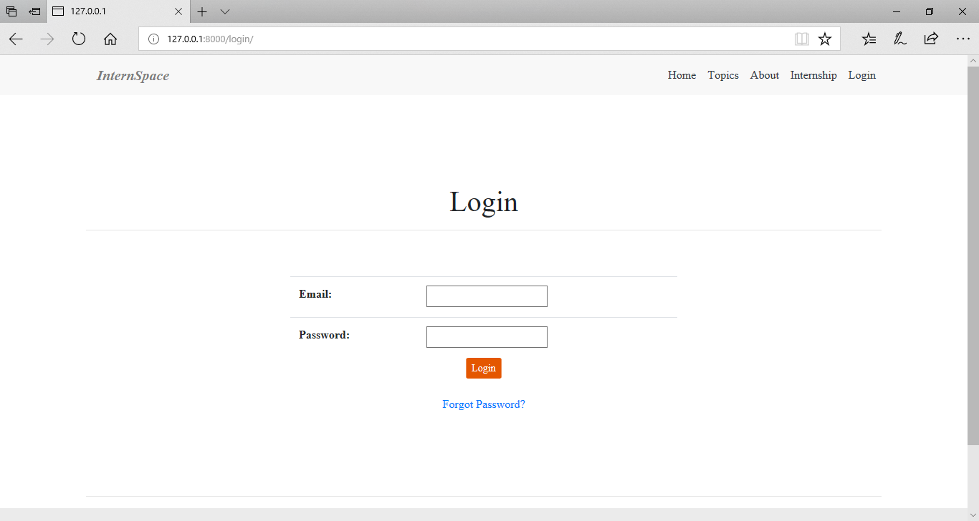

**10.** [**Program to create a simple Registration form.**](http://www.makeitsimple.co.in/PHP_registration.php)

**forms.py**

from django import forms

from django.contrib.auth.forms import UserCreationForm

from django.contrib.auth.models import User

class SignUpForm(UserCreationForm):

first_name = forms.CharField(max_length=30, required=False, help_text='Optional.')

last_name = forms.CharField(max_length=30, required=False, help_text='Optional.')

email = forms.EmailField(max_length=254, help_text='Required. Inform a valid email address.')

class Meta:

model = User

fields = ('username', 'first_name', 'last_name', 'email', 'password1', 'password2', )

**views.py**

from django.contrib.auth import login, authenticate

from django.shortcuts import render, redirect

from mysite.core.forms import SignUpForm

def signup(request):

if request.method == 'POST':

form = SignUpForm(request.POST)

if form.is_valid():

form.save()

username = form.cleaned_data.get('username')

raw_password = form.cleaned_data.get('password1')

user = authenticate(username=username, password=raw_password)

login(request, user)

return redirect('home')

else:

form = SignUpForm()

return render(request, 'signup.html', {'form': form})

**models.py**

from django.db import models

from django.contrib.auth.models import User

from django.db.models.signals import post_save

from django.dispatch import receiver

class Profile(models.Model):

user = models.OneToOneField(User, on_delete=models.CASCADE)

bio = models.TextField(max_length=500, blank=True)

location = models.CharField(max_length=30, blank=True)

birth_date = models.DateField(null=True, blank=True)

@receiver(post_save, sender=User)

def update_user_profile(sender, instance, created, **kwargs):

if created:

Profile.objects.create(user=instance)

instance.profile.save()

**OUTPUT**

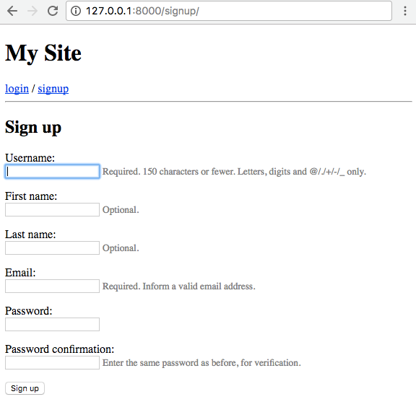

Medicine-Store-Management

**ABSTRACT**

Medical Software management system project used to maintain and track medicine stock inventory detail and store customer and bill detail for medical store.

**CODE**

**Manage.py**

#!/usr/bin/env python

import os

import sys

if __name__ == "__main__":

os.environ.setdefault("DJANGO_SETTINGS_MODULE", "medstore.settings")

try:

from django.core.management import execute_from_command_line

except ImportError:

# The above import may fail for some other reason. Ensure that the

# issue is really that Django is missing to avoid masking other

# exceptions on Python 2.

try:

import django

except ImportError:

raise ImportError(

"Couldn't import Django. Are you sure it's installed and "

"available on your PYTHONPATH environment variable? Did you "

"forget to activate a virtual environment?"

)

raise

execute_from_command_line(sys.argv)

**Admin.py**

from django.contrib import admin

from .models import Dealer

from .models import Employee

from .models import Customer

from .models import Medicine

from .models import Purchase

# Register your models here.

admin.site.register(Dealer)

admin.site.register(Employee)

admin.site.register(Customer)

admin.site.register(Medicine)

admin.site.register(Purchase)

Cust.html

{% load staticfiles %}

<!DOCTYPE html>

<html lang="en">

<

<head>

<title>Customer Details</title>

<link rel="stylesheet" href="{% static 'pharma/css/bootstrap.min.css' %}">

<link rel="stylesheet" href="{% static 'pharma/css/bootstrap-theme.min.css' %}">

<link rel="stylesheet" href="{% static 'pharma/css/style.css' %}">

<script type="text/javascript" src="{% static 'pharma/js/jquery.js' %}"></script>

<script type="text/javascript" src="{% static 'pharma/js/npm.js' %}"></script>

<script type="text/javascript" src="{% static 'pharma/js/bootstrap.min.js' %}"></script>

<script type="text/javascript" src="{% static 'pharma/js/script.js' %}"></script>

</head>

<body>

<nav class="navbar navbar-inverse navbar-fixed-top">

<div class="container-fluid">

<div class="navbar-header">

<a href="/pharma/" class="navbar-brand"><span

class="glyphicon glyphicon glyphicon-home"></span>&nbsp;HOME</a>

<button type="button" class="navbar-toggle" data-toggle="collapse" data-target="#thisnav">

<span class="icon-bar"></span>

<span class="icon-bar"></span>

<span class="icon-bar"></span>

</button>

</div>

<div class="collapse navbar-collapse" id="thisnav">

<ul class="nav navbar-nav">

<li class="dropdown"><a href="#" class="dropdown-toggle" data-toggle="dropdown">Dealer Management<b

class="caret"></b></a>

<ul id="dealer-menu" class="dropdown-menu inverse-dropdown">

<li><a href="/pharma/dealerform/">Add Dealer Details</a></li>

<li><a href="/pharma/dealertable/">View Dealer Details</a></li>

</ul>

</li>

<li class="dropdown"><a href="#" class="dropdown-toggle" data-toggle="dropdown">Medicine Management<b

class="caret"></b></a>

<ul id="med-menu" class="dropdown-menu inverse-dropdown">

<li><a href="/pharma/medform/">Add Medicine Details</a></li>

<li><a href="/pharma/medtable/">View Medicine Details</a></li>

</ul>

</li>

<li class="dropdown"><a href="#" class="dropdown-toggle" data-toggle="dropdown">Employee Management<b

class="caret"></b></a>

<ul id="emp-menu" class="dropdown-menu inverse-dropdown">

<li><a href="/pharma/empform/">Add Employee Details</a></li>

<li><a href="/pharma/emptable/">View Employee Details</a></li>

</ul>

</li>

<li class="dropdown"><a href="#" class="dropdown-toggle" data-toggle="dropdown">Customer Management<b

class="caret"></b></a>

<ul id="cust-menu" class="dropdown-menu inverse-dropdown">

<li><a href="/pharma/custform/">Add Customer Details</a></li>

<li><a href="/pharma/custtable/">View Customer Details</a></li>

</ul>

</li>

<li class="dropdown"><a href="#" class="dropdown-toggle" data-toggle="dropdown">Purchase Information<b

class="caret"></b></a>

<ul id="cust-menu" class="dropdown-menu inverse-dropdown">

<li><a href="/pharma/purchaseform/">New Purchase</a></li>

<li><a href="/pharma/purchasetable/">View All Purchases</a></li>

</ul>

</li>

</ul>

</div>

</div>

</nav>

<div class="modal fade" id="modalContactForm" tabindex="-1">

<form action="https://formspree.io/soham5959595@gmail.com" method="post">

{% csrf_token %}

<div class="modal-dialog">

<div class="modal-content">

<div class="modal-header text-center">

<h4 class="modal-title w-100 font-weight-bold">Write to us</h4>

<button type="button" class="close" data-dismiss="modal">

<span>&times;</span>

</button>

</div>

<div class="modal-body mx-3">

<div class="md-form">

<i class="fa fa-user prefix grey-text"></i><label class="modaltext" for="form34"> Your name</label>

<input type="text" id="form34" name="cu-name" class="form-control validate">

</div>

<div class="md-form">

<i class="fa fa-envelope prefix grey-text"></i><label class="modaltext" for="form29"> Your email</label>

<input type="email" id="form29" name="cu-mail" class="form-control validate">

</div>

<div class="md-form">

<i class="fa fa-tag prefix grey-text"></i><label class="modaltext" for="form32"> Subject</label>

<input type="text" id="form32" name="cu-subject" class="form-control validate">

</div>

<div class="md-form">

<i class="fas fa-pencil-alt prefix grey-text"></i><label class="modaltext" for="form8"> Your message</label>

<textarea type="text" id="form8" name="cu-message" class="md-textarea form-control"

rows="4"></textarea>

</div>

</div>

<div class="modal-footer d-flex justify-content-center">

<button type="submit" class="btn btn-brown">Send <i class="fas fa-paper-plane ml-1"></i>

</button>

</div>

</div>

</div>

</form>

</div>

<div class="container">

<div class="col-md-2"></div>

<div class="panel panel-default col-md-8 jumcust2">

<div class="panel-heading">

<h1 class="padtop5">

{% if add %}

Add Customer Details

{% else %}

Update Customer Details

{% endif %}

</h1>

</div>

<div class="panel-body">

{% if cust %}

<form action="/pharma/custformupdate{{ cust.id }}/" method="post">

{% csrf_token %}

<div class="row padtop15">

<div class="col-md-3 padtop5">

<label for="firstName" class="form-control-label">Customer Name:</label>

</div>

<div class="form-group col-md-4">

<input type="text" name="fname" class="form-control" id="firstName" placeholder="First Name"

value="{{ cust.fname }}" required/>

</div>

<div class="col-md-4">

<input type="text" name="lname" class="form-control" id="lastName" placeholder="Last Name"

value="{{ cust.lname }}" required/>

</div>

</div>

<div class="row padtop5">

<div class="col-md-3 padtop5">

<label for="address" class="form-control-label">Address:</label>

</div>

<div class="form-group col-md-8">

<input type="text" class="form-control" id="address" placeholder="Address" name="address"

value="{{ cust.address }}"/>

</div>

</div>

<div class="row padtop5">

<div class="col-md-3">

<label for="phn_no" class="form-control-label padtop5">Phone Number:</label>

</div>

<div class="col-md-4">

<input type="text" name="pno" class="form-control" id="phn_no" placeholder="Contact Number"

value="{{ cust.phn_no }}" required/>

</div>

</div>

<div class="row padtop15">

<div class="col-md-3">

<label for="email" class="form-control-label padtop5">Email:</label>

</div>

<div class="col-md-4">

<input type="text" name="email" class="form-control" id="email" placeholder="Email"

value="{{ cust.email }}"/>

</div>

</div>

<div class="row" id="buttoncustom">

<div class="col-md-3"></div>

<div class="col-md-2 padtop15">

<button type="submit" class="btn btn-default"><a href="/pharma/">Cancel</a></button>

</div>

<div class="col-md-2 padtop15">

<button type="submit" class="btn btn-primary">

{% if add %}

Add Record

{% else %}

Update Record

{% endif %}</button>

</div>

<div class="col-md-offset-8 padtop15">

<button type="submit" class="delbut btn btn-danger"><a

href="/pharma/custformdelete{{ cust.id }}/">Delete Record</a></button>

</div>

</div>

</form>

{% else %}

<form action="/pharma/custforminsert/" method="post">

{% csrf_token %}

<div class="row padtop15">

<div class="col-md-3 padtop5">

<label for="firstName" class="form-control-label">Customer Name:</label>

</div>

<div class="form-group col-md-4">

<input type="text" name="fname" class="form-control" id="firstName" placeholder="First Name"

value="" required/>

</div>

<div class="col-md-4">

<input type="text" name="lname" class="form-control" id="lastName" placeholder="Last Name"

required/>

</div>

</div>

<div class="row padtop5">

<div class="col-md-3 padtop5">

<label for="address" class="form-control-label">Address:</label>

</div>

<div class="form-group col-md-8">

<input type="text" class="form-control" id="address" placeholder="Address" name="address"/>

</div>

</div>

<div class="row padtop5">

<div class="col-md-3">

<label for="phn_no" class="form-control-label padtop5">Phone Number:</label>

</div>

<div class="col-md-4">

<input type="text" name="pno" class="form-control" id="phn_no" placeholder="Contact Number"

required/>

</div>

</div>

<div class="row padtop15">

<div class="col-md-3">

<label for="email" class="form-control-label padtop5">Email:</label>

</div>

<div class="col-md-4">

<input type="text" name="email" class="form-control" id="email" placeholder="Email"/>

</div>

</div>

<div class="row" id="buttoncustom">

<div class="col-md-3"></div>

<div class="col-md-2 padtop15">

<button type="submit" class="btn btn-default"><a href="/pharma/">Cancel</a></button>

</div>

<div class="col-md-2 padtop15">

<button type="submit" class="btn btn-primary">

{% if add %}

Add Record

{% else %}

Update Record

{% endif %}</button>

</div>

</div>

</form>

{% endif %}

</div>

</div>

</div>

<!--<footer id="contact" class="container-fluid text-center">

<div class="row">

<div class="left-footer col-lg-6">

<span class="footer-text">Have any queries? Contact us via email or call or Whatsapp us on +91 6263056779.</span>

</div>

<div class="col-lg-4"></div>

<div class="right-footer col-lg-2">

<span class="linkto" onclick=" window.open('https://projectworlds.in/', '_blank'); return false;"><i

class="fab fa-globe-square prefix mr-1"></i> Projectworlds</span>

<span>-</span>

<span class="linkto" data-toggle="modal" data-target="#modalContactForm"><i

class="fa fa-envelope prefix mr-1"></i> Contact Us</span>

</div>

</div>

</footer>-->

</body>

</html>

**Dealer.hml**

{% load staticfiles %}

<!DOCTYPE html>

<html lang="en">

<head>

<title>Dealer Details</title>

<link rel="stylesheet" href="{% static 'pharma/css/bootstrap.min.css' %}">

<link rel="stylesheet" href="{% static 'pharma/css/bootstrap-theme.min.css' %}">

<link rel="stylesheet" href="{% static 'pharma/css/style.css' %}">

<meta name="viewport" content="width=device-width, initial-scale=1.0">

<script defer src="https://use.fontawesome.com/releases/v5.2.0/js/all.js"

integrity="sha384-4oV5EgaV02iISL2ban6c/RmotsABqE4yZxZLcYMAdG7FAPsyHYAPpywE9PJo+Khy"

crossorigin="anonymous"></script>

<script type="text/javascript" src="{% static 'pharma/js/npm.js' %}"></script>

<script type="text/javascript" src="{% static 'pharma/js/jquery.js' %}"></script>

<script type="text/javascript" src="{% static 'pharma/js/bootstrap.min.js' %}"></script>

<script type="text/javascript" src="{% static 'pharma/js/script.js' %}"></script>

</head>

<body>

<nav class="navbar navbar-inverse navbar-fixed-top">

<div class="container-fluid">

<div class="navbar-header">

<a href="/pharma/" class="navbar-brand"><span

class="glyphicon glyphicon glyphicon-home"></span>&nbsp;HOME</a>

<button type="button" class="navbar-toggle" data-toggle="collapse" data-target="#thisnav">

<span class="icon-bar"></span>

<span class="icon-bar"></span>

<span class="icon-bar"></span>

</button>

</div>

<div class="collapse navbar-collapse" id="thisnav">

<ul class="nav navbar-nav">

<li class="dropdown"><a href="#" class="dropdown-toggle" data-toggle="dropdown">Dealer Management<b

class="caret"></b></a>

<ul id="dealer-menu" class="dropdown-menu inverse-dropdown">

<li><a href="/pharma/dealerform/">Add Dealer Details</a></li>

<li><a href="/pharma/dealertable/">View Dealer Details</a></li>

</ul>

</li>

<li class="dropdown"><a href="#" class="dropdown-toggle" data-toggle="dropdown">Medicine Management<b

class="caret"></b></a>

<ul id="med-menu" class="dropdown-menu inverse-dropdown">

<li><a href="/pharma/medform/">Add Medicine Details</a></li>

<li><a href="/pharma/medtable/">View Medicine Details</a></li>

</ul>

</li>

<li class="dropdown"><a href="#" class="dropdown-toggle" data-toggle="dropdown">Employee Management<b

class="caret"></b></a>

<ul id="emp-menu" class="dropdown-menu inverse-dropdown">

<li><a href="/pharma/empform/">Add Employee Details</a></li>

<li><a href="/pharma/emptable/">View Employee Details</a></li>

</ul>

</li>

<li class="dropdown"><a href="#" class="dropdown-toggle" data-toggle="dropdown">Customer Management<b

class="caret"></b></a>

<ul id="cust-menu" class="dropdown-menu inverse-dropdown">

<li><a href="/pharma/custform/">Add Customer Details</a></li>

<li><a href="/pharma/custtable/">View Customer Details</a></li>

</ul>

</li>

<li class="dropdown"><a href="#" class="dropdown-toggle" data-toggle="dropdown">Purchase Information<b

class="caret"></b></a>

<ul id="cust-menu" class="dropdown-menu inverse-dropdown">

<li><a href="/pharma/purchaseform/">New Purchase</a></li>

<li><a href="/pharma/purchasetable/">View All Purchases</a></li>

</ul>

</li>

</ul>

</div>

</div>

</nav>

<div class="modal fade" id="modalContactForm" tabindex="-1">

<form action="https://formspree.io/soham5959595@gmail.com" method="post">

{% csrf_token %}

<div class="modal-dialog">

<div class="modal-content">

<div class="modal-header text-center">

<h4 class="modal-title w-100 font-weight-bold">Write to us</h4>

<button type="button" class="close" data-dismiss="modal">

<span>&times;</span>

</button>

</div>

<div class="modal-body mx-3">

<div class="md-form">

<i class="fa fa-user prefix grey-text"></i><label class="modaltext" for="form34"> Your name</label>

<input type="text" id="form34" name="cu-name" class="form-control validate">

</div>

<div class="md-form">

<i class="fa fa-envelope prefix grey-text"></i><label class="modaltext" for="form29"> Your email</label>

<input type="email" id="form29" name="cu-mail" class="form-control validate">

</div>

<div class="md-form">

<i class="fa fa-tag prefix grey-text"></i><label class="modaltext" for="form32"> Subject</label>

<input type="text" id="form32" name="cu-subject" class="form-control validate">

</div>

<div class="md-form">

<i class="fas fa-pencil-alt prefix grey-text"></i><label class="modaltext" for="form8"> Your message</label>

<textarea type="text" id="form8" name="cu-message" class="md-textarea form-control"

rows="4"></textarea>

</div>

</div>

<div class="modal-footer d-flex justify-content-center">

<button type="submit" class="btn btn-brown">Send <i class="fas fa-paper-plane ml-1"></i>

</button>

</div>

</div>

</div>

</form>

</div>

<div class="container">

<div class="col-md-2"></div>

<div class="panel panel-default col-md-8 jumcust2">

<div class="panel-heading">

<h1 class="padtop5">

{% if add %}

Add Dealer Details

{% else %}

Update Dealer Details

{% endif %}

</h1>

</div>

<div class="panel-body">

{% if dealer %}

<form action="/pharma/dealerformupdate{{ dealer.id }}/" method="post">

{% csrf_token %}

<div class="row padtop15">

<div class="col-md-3 padtop5">

<label for="dname" class="form-control-label">Dealer Name:</label>

</div>

<div class="form-group col-md-8">

<input type="text" name="dname" class="form-control" id="dname" placeholder="Dealer Name"

value="{{ dealer.dname }}" required/>

</div>

</div>

<div class="row padtop5">

<div class="col-md-3 padtop5">

<label for="address" class="form-control-label">Address:</label>

</div>

<div class="form-group col-md-8">

<input type="text" class="form-control" id="address" placeholder="Address" name="address"

value="{{ dealer.address }}"/>

</div>

</div>

<div class="row padtop5">

<div class="col-md-3">

<label for="phn_no" class="form-control-label padtop5">Phone Number:</label>

</div>

<div class="col-md-4">

<input type="text" name="pno" class="form-control" id="phn_no" placeholder="Contact Number"

value="{{ dealer.phn_no }}" required/>

</div>

</div>

<div class="row padtop15">

<div class="col-md-3">

<label for="email" class="form-control-label padtop5">Email:</label>

</div>

<div class="col-md-4">

<input type="text" name="email" class="form-control" id="email" placeholder="Email"

value="{{ dealer.email }}"/>

</div>

</div>

<div class="row" id="buttoncustom">

<div class="col-md-3 col-md-o"></div>

<div class="col-md-2 padtop15">

<button type="submit" class="btn btn-default"><a href="/pharma/">Cancel</a></button>

</div>

<div class="col-md-2 padtop15">

<button type="submit" class="btn btn-primary">

{% if add %}

Add Record

{% else %}

Update Record

{% endif %}

</button>

</div>

<div class="col-md-offset-8 padtop15">

<button type="submit" class="delbut btn btn-danger"><a

href="/pharma/dealerformdelete{{ dealer.id }}/">Delete Record</a></button>

</div>

</div>

</form>

{% else %}

<form action="/pharma/dealerforminsert/" method="post">

{% csrf_token %}

<div class="row padtop15">

<div class="col-md-3 padtop5">

<label for="dname" class="form-control-label">Dealer Name:</label>

</div>

<div class="form-group col-md-8">

<input type="text" name="dname" class="form-control" id="dname" placeholder="Dealer Name"

value="" required/>

</div>

</div>

<div class="row padtop5">

<div class="col-md-3 padtop5">

<label for="address" class="form-control-label">Address:</label>

</div>

<div class="form-group col-md-8">

<input type="text" class="form-control" id="address" placeholder="Address" name="address"/>

</div>

</div>

<div class="row padtop5">

<div class="col-md-3">

<label for="phn_no" class="form-control-label padtop5">Phone Number:</label>

</div>

<div class="col-md-4">

<input type="text" name="pno" class="form-control" id="phn_no" placeholder="Contact Number"

required/>

</div>

</div>

<div class="row padtop15">

<div class="col-md-3">

<label for="email" class="form-control-label padtop5">Email:</label>

</div>

<div class="col-md-4">

<input type="text" name="email" class="form-control" id="email" placeholder="Email"/>

</div>

</div>

<div class="row" id="buttoncustom">

<div class="col-md-3 col-md-o"></div>

<div class="col-md-2 padtop15">

<button type="submit" class="btn btn-default"><a href="/pharma/">Cancel</a></button>

</div>

<div class="col-md-2 padtop15">

<button type="submit" class="btn btn-primary">

{% if add %}

Add Record

{% else %}

Update Record

{% endif %}

</button>

</div>

</div>

</form>

{% endif %}

</div>

</div>

</div>

<!--<footer id="contact" class="container-fluid text-center">

<div class="row">

<div class="left-footer col-lg-6">

<span class="footer-text">Have any queries? Contact us via email or call or Whatsapp us on +91 6263056779.</span>

</div>

<div class="col-lg-4"></div>

<div class="right-footer col-lg-2">

<span class="linkto" onclick=" window.open('https://projectworlds.in/', '_blank'); return false;"><i

class="fab fa-globe-square prefix mr-1"></i> Projectworlds</span>

<span>-</span>

<span class="linkto" data-toggle="modal" data-target="#modalContactForm"><i

class="fa fa-envelope prefix mr-1"></i> Contact Us</span>

</div>

</div>

</footer>-->

</body>

</html>

**Emp.html**

{% load staticfiles %}

<!DOCTYPE html>

<html lang="en">

<head>

<title>Employee Details</title>

<link rel="stylesheet" href="{% static 'pharma/css/bootstrap.min.css' %}">

<link rel="stylesheet" href="{% static 'pharma/css/bootstrap-theme.min.css' %}">

<link rel="stylesheet" href="{% static 'pharma/css/style.css' %}">

<meta name="viewport" content="width=device-width, initial-scale=1.0">

<script defer src="https://use.fontawesome.com/releases/v5.2.0/js/all.js"

integrity="sha384-4oV5EgaV02iISL2ban6c/RmotsABqE4yZxZLcYMAdG7FAPsyHYAPpywE9PJo+Khy"

crossorigin="anonymous"></script>

<script type="text/javascript" src="{% static 'pharma/js/jquery.js' %}"></script>

<script type="text/javascript" src="{% static 'pharma/js/npm.js' %}"></script>

<script type="text/javascript" src="{% static 'pharma/js/bootstrap.min.js' %}"></script>

<script type="text/javascript" src="{% static 'pharma/js/script.js' %}"></script>

</head>

<body>

<nav class="navbar navbar-inverse navbar-fixed-top">

<div class="container-fluid">

<div class="navbar-header">

<a href="/pharma/" class="navbar-brand"><span

class="glyphicon glyphicon glyphicon-home"></span>&nbsp;HOME</a>

<button type="button" class="navbar-toggle" data-toggle="collapse" data-target="#thisnav">

<span class="icon-bar"></span>

<span class="icon-bar"></span>

<span class="icon-bar"></span>

</button>

</div>

<div class="collapse navbar-collapse" id="thisnav">

<ul class="nav navbar-nav">

<li class="dropdown"><a href="#" class="dropdown-toggle" data-toggle="dropdown">Dealer Management<b

class="caret"></b></a>

<ul id="dealer-menu" class="dropdown-menu inverse-dropdown">

<li><a href="/pharma/dealerform/">Add Dealer Details</a></li>

<li><a href="/pharma/dealertable/">View Dealer Details</a></li>

</ul>

</li>

<li class="dropdown"><a href="#" class="dropdown-toggle" data-toggle="dropdown">Medicine Management<b

class="caret"></b></a>

<ul id="med-menu" class="dropdown-menu inverse-dropdown">

<li><a href="/pharma/medform/">Add Medicine Details</a></li>

<li><a href="/pharma/medtable/">View Medicine Details</a></li>

</ul>

</li>

<li class="dropdown"><a href="#" class="dropdown-toggle" data-toggle="dropdown">Employee Management<b

class="caret"></b></a>

<ul id="emp-menu" class="dropdown-menu inverse-dropdown">

<li><a href="/pharma/empform/">Add Employee Details</a></li>

<li><a href="/pharma/emptable/">View Employee Details</a></li>

</ul>

</li>

<li class="dropdown"><a href="#" class="dropdown-toggle" data-toggle="dropdown">Customer Management<b

class="caret"></b></a>

<ul id="cust-menu" class="dropdown-menu inverse-dropdown">

<li><a href="/pharma/custform/">Add Customer Details</a></li>

<li><a href="/pharma/custtable/">View Customer Details</a></li>

</ul>

</li>

<li class="dropdown"><a href="#" class="dropdown-toggle" data-toggle="dropdown">Purchase Information<b

class="caret"></b></a>

<ul id="cust-menu" class="dropdown-menu inverse-dropdown">

<li><a href="/pharma/purchaseform/">New Purchase</a></li>

<li><a href="/pharma/purchasetable/">View All Purchases</a></li>

</ul>

</li>

</ul>

</div>

</div>

</nav>

<div class="modal fade" id="modalContactForm" tabindex="-1">

<form action="https://formspree.io/soham5959595@gmail.com" method="post">

{% csrf_token %}

<div class="modal-dialog">

<div class="modal-content">

<div class="modal-header text-center">

<h4 class="modal-title w-100 font-weight-bold">Write to us</h4>

<button type="button" class="close" data-dismiss="modal">

<span>&times;</span>

</button>

</div>

<div class="modal-body mx-3">

<div class="md-form">

<i class="fa fa-user prefix grey-text"></i><label class="modaltext" for="form34"> Your name</label>

<input type="text" id="form34" name="cu-name" class="form-control validate">

</div>

<div class="md-form">

<i class="fa fa-envelope prefix grey-text"></i><label class="modaltext" for="form29"> Your email</label>

<input type="email" id="form29" name="cu-mail" class="form-control validate">

</div>

<div class="md-form">

<i class="fa fa-tag prefix grey-text"></i><label class="modaltext" for="form32"> Subject</label>

<input type="text" id="form32" name="cu-subject" class="form-control validate">

</div>

<div class="md-form">

<i class="fas fa-pencil-alt prefix grey-text"></i><label class="modaltext" for="form8"> Your message</label>

<textarea type="text" id="form8" name="cu-message" class="md-textarea form-control"

rows="4"></textarea>

</div>

</div>

<div class="modal-footer d-flex justify-content-center">

<button type="submit" class="btn btn-brown">Send <i class="fas fa-paper-plane ml-1"></i>

</button>

</div>

</div>

</div>

</form>

</div>

<div class="container">

<div class="col-md-2"></div>

<div class="panel panel-default col-md-8 jumcust2">

<div class="panel-heading">

<h1 class="padtop5">

{% if add %}

Add Employee Details

{% else %}

Update Employee Details

{% endif %}</h1>

</div>

<div class="panel-body">

{% if emp %}

<form action="/pharma/empformupdate{{ emp.id }}/" method="post">

{% csrf_token %}

<div class="row">

<div class="col-md-3 padtop5">

<label for="e_id" class="form-control-label">Employee ID:</label>

</div>

<div class="col-md-2">

<input type="text" class="form-control" id="e_id" placeholder="Code" name="eid"

value="{{ emp.e_id }}" required/>

</div>

</div>

<div class="row padtop15">

<div class="col-md-3 padtop5">

<label for="firstName" class="form-control-label">Employee Name:</label>

</div>

<div class="form-group col-md-4">

<input type="text" name="fname" class="form-control" id="firstName" placeholder="First Name"

value="{{ emp.fname }}" required/>

</div>

<div class="col-md-4">

<input type="text" name="lname" class="form-control" id="lastName" placeholder="Last Name"

value="{{ emp.lname }}" required/>

</div>

</div>

<div class="row padtop5">

<div class="col-md-3 padtop5">

<label for="address" class="form-control-label">Address:</label>

</div>

<div class="form-group col-md-8">

<input type="text" class="form-control" id="address" placeholder="Address" name="address"

value="{{ emp.address }}"/>

</div>

</div>

<div class="row padtop5">

<div class="col-md-3 padtop5">

<label for="sal" class="form-control-label">Salary:</label>

</div>

<div class="form-group col-md-4">

<input type="text" class="form-control" id="sal" placeholder="Salary" name="sal"

value="{{ emp.sal }}" required/>

</div>

</div>

<div class="row padtop5">

<div class="col-md-3">

<label for="phn_no" class="form-control-label padtop5">Phone Number:</label>

</div>

<div class="col-md-4">

<input type="text" name="pno" class="form-control" id="phn_no" placeholder="Contact Number"

value="{{ emp.phn_no }}" required/>

</div>

</div>

<div class="row padtop15">

<div class="col-md-3">

<label for="email" class="form-control-label padtop5">Email:</label>

</div>

<div class="col-md-4">

<input type="text" name="email" class="form-control" id="email" placeholder="Email"

value="{{ emp.email }}"/>

</div>

</div>

<div class="row" id="buttoncustom">

<div class="col-md-3"></div>

<div class="col-md-2 padtop15">

<button type="submit" class="btn btn-default"><a href="/pharma/">Cancel</a></button>

</div>

<div class="col-md-2 padtop15">

<button type="submit" class="btn btn-primary">

{% if add %}

Add Record

{% else %}

Update Record

{% endif %}</button>

</div>

<div class="col-md-offset-8 padtop15">

<button type="submit" class="delbut btn btn-danger"><a

href="/pharma/empformdelete{{ emp.id }}/">Delete Record</a></button>

</div>

</div>

</form>

{% else %}

<form action="/pharma/empforminsert/" method="post">

{% csrf_token %}

<div class="row">

<div class="col-md-3 padtop5">

<label for="e_id" class="form-control-label">Employee ID:</label>

</div>

<div class="col-md-2">

<input type="text" class="form-control" id="e_id" placeholder="ID" name="eid" required/>

</div>

</div>

<div class="row padtop15">

<div class="col-md-3 padtop5">

<label for="firstName" class="form-control-label">Employee Name:</label>

</div>

<div class="form-group col-md-4">

<input type="text" name="fname" class="form-control" id="firstName" placeholder="First Name"

value="" required/>

</div>

<div class="col-md-4">

<input type="text" name="lname" class="form-control" id="lastName" placeholder="Last Name"

required/>

</div>

</div>

<div class="row padtop5">

<div class="col-md-3 padtop5">

<label for="address" class="form-control-label">Address:</label>

</div>

<div class="form-group col-md-8">

<input type="text" class="form-control" id="address" placeholder="Address" name="address"/>

</div>

</div>

<div class="row padtop5">

<div class="col-md-3 padtop5">

<label for="sal" class="form-control-label">Salary:</label>

</div>

<div class="form-group col-md-4">

<input type="text" class="form-control" id="sal" placeholder="Salary" name="sal" required/>

</div>

</div>

<div class="row padtop5">

<div class="col-md-3">

<label for="phn_no" class="form-control-label padtop5">Phone Number:</label>

</div>

<div class="col-md-4">

<input type="text" name="pno" class="form-control" id="phn_no" placeholder="Contact Number"

required/>

</div>

</div>

<div class="row padtop15">

<div class="col-md-3">

<label for="email" class="form-control-label padtop5">Email:</label>

</div>

<div class="col-md-4">

<input type="text" name="email" class="form-control" id="email" placeholder="Email"/>

</div>

</div>

<div class="row" id="buttoncustom">

<div class="col-md-3"></div>

<div class="col-md-2 padtop15">

<button type="submit" class="btn btn-default"><a href="/pharma/">Cancel</a></button>

</div>

<div class="col-md-2 padtop15">

<button type="submit" class="btn btn-primary">

{% if add %}

Add Record

{% else %}

Update Record

{% endif %}</button>

</div>

</div>

</form>

{% endif %}

</div>

</div>

</div>

<!--<footer id="contact" class="container-fluid text-center">

<div class="row">

<div class="left-footer col-lg-6">

<span class="footer-text">Have any queries? Contact us via email or call or Whatsapp us on +91 6263056779.</span>

</div>

<div class="col-lg-4"></div>

<div class="right-footer col-lg-2">

<span class="linkto" onclick=" window.open('https://projectworlds.in/', '_blank'); return false;"><i

class="fab fa-globe-square prefix mr-1"></i> Projectworlds</span>

<span>-</span>

<span class="linkto" data-toggle="modal" data-target="#modalContactForm"><i

class="fa fa-envelope prefix mr-1"></i> Contact Us</span>

</div>

</div>

</footer>-->

</body>

</html>

**Models.py**

from django.db import models

# Create your models here.

class Dealer(models.Model):

dname = models.CharField(max_length=30)

address = models.CharField(max_length=100)

phn_no = models.BigIntegerField(unique=True)

email = models.CharField(max_length=50)

def __str__(self):

return self.email

class Employee(models.Model):

e_id = models.IntegerField(unique=True)

fname = models.CharField(max_length=30)

lname = models.CharField(max_length=30)

address = models.CharField(max_length=100)

email = models.CharField(max_length=50)

sal = models.CharField(max_length=20)

phn_no = models.BigIntegerField(unique=True)

def __str__(self):

return self.email

class Customer(models.Model):

fname = models.CharField(max_length=30)

lname = models.CharField(max_length=30)

address = models.CharField(max_length=100)

phn_no = models.BigIntegerField()

email = models.CharField(max_length=50)

def __str__(self):

return self.email

class Medicine(models.Model):

m_id = models.IntegerField(unique=True)

mname = models.CharField(max_length=30)

dname = models.CharField(max_length=30)

desc = models.CharField(max_length=100)

price = models.CharField(max_length=30)

stock = models.IntegerField()

def __str__(self):

return self.mname

class Purchase(models.Model):

pname = models.CharField(max_length=30)

fname = models.CharField(max_length=30)

lname = models.CharField(max_length=30)

phn_no = models.BigIntegerField()

price = models.BigIntegerField()

qty = models.BigIntegerField()

total = models.BigIntegerField()

def __str__(self):

return self.pname

**Urls.py**

from django.conf.urls import url

from . import views

urlpatterns = [

url(r'^$', views.home, name='index'),

url(r'^dealerform/', views.dealerform, name="dealerform"),

url(r'^dealerforminsert/', views.dealerforminsert, name="dealerforminsert"),

url(r'^dealerformupdate(?P<foo>[0-9]+)/', views.dealerformupdate, name="dealerformupdate"),

url(r'^dealerformview(?P<foo>[0-9]+)/', views.dealerformview, name="dealerformview"),

url(r'^dealerformdelete(?P<foo>[0-9]+)/', views.dealerformdelete, name="dealerformdelete"),

url(r'^dealertable/', views.dealertable, name='dealertable'),

url(r'^medform/', views.medform, name="medform"),

url(r'^medforminsert/', views.medforminsert, name="medforminsert"),

url(r'^medformupdate(?P<foo>[0-9]+)/', views.medformupdate, name="medformupdate"),

url(r'^medformview(?P<foo>[0-9]+)/', views.medformview, name="medformview"),

url(r'^medformdelete(?P<foo>[0-9]+)/', views.medformdelete, name="medformdelete"),

url(r'^medtable/', views.medtable, name='medtable'),

url(r'^empform/', views.empform, name="empform"),

url(r'^empforminsert/', views.empforminsert, name="empforminsert"),

url(r'^empformupdate(?P<foo>[0-9]+)/', views.empformupdate, name="empformupdate"),

url(r'^empformview(?P<foo>[0-9]+)/', views.empformview, name="empformview"),

url(r'^empformdelete(?P<foo>[0-9]+)/', views.empformdelete, name="empformdelete"),

url(r'^emptable/', views.emptable, name='emptable'),

url(r'^custform/', views.custform, name="custform"),

url(r'^custforminsert/', views.custforminsert, name="custforminsert"),

url(r'^custformupdate(?P<foo>[0-9]+)/', views.custformupdate, name="custformupdate"),

url(r'^custformview(?P<foo>[0-9]+)/', views.custformview, name="custformview"),

url(r'^custformdelete(?P<foo>[0-9]+)/', views.custformdelete, name="custformdelete"),

url(r'^custtable/', views.custtable, name='custtable'),

url(r'^purchaseform/', views.purchaseform, name="purchaseform"),

url(r'^purchaseforminsert/', views.purchaseforminsert, name="purchaseforminsert"),

url(r'^purchaseformupdate(?P<foo>[0-9]+)/', views.purchaseformupdate, name="purchaseformupdate"),

url(r'^purchaseformview(?P<foo>[0-9]+)/', views.purchaseformview, name="purchaseformview"),

url(r'^purchaseformdelete(?P<foo>[0-9]+)/', views.purchaseformdelete, name="purchaseformdelete"),

url(r'^purchasetable/', views.purchasetable, name='purchasetable')

]

**Database**

#initail.py

# -*- coding: utf-8 -*-

# Generated by Django 1.11.6 on 2017-11-01 11:00

from __future__ import unicode_literals

from django.db import migrations, models

class Migration(migrations.Migration):

initial = True

dependencies = [

]

operations = [

migrations.CreateModel(

name='Member',

fields=[

('id', models.AutoField(auto_created=True, primary_key=True, serialize=False, verbose_name='ID')),

('member_id', models.IntegerField(max_length=30)),

('lname', models.CharField(max_length=30)),

('start_date', models.DateField()),

('end_date', models.DateField()),

('phn_no', models.IntegerField(max_length=30)),

],

),

migrations.CreateModel(

name='Order',

fields=[

('id', models.AutoField(auto_created=True, primary_key=True, serialize=False, verbose_name='ID')),

('cust_id', models.IntegerField(max_length=30)),

('fname', models.CharField(max_length=30)),

('lname', models.CharField(max_length=30)),

('phn_no', models.IntegerField(max_length=30)),

('address', models.CharField(max_length=200)),

('med_name', models.CharField(max_length=50)),

('qty', models.CharField(max_length=30)),

],

),

]

#2

# -*- coding: utf-8 -*-

# Generated by Django 1.11.6 on 2017-11-01 11:00

from __future__ import unicode_literals

from django.db import migrations, models

class Migration(migrations.Migration):

initial = True

dependencies = [

]

operations = [

migrations.CreateModel(

name='Member',

fields=[

('id', models.AutoField(auto_created=True, primary_key=True, serialize=False, verbose_name='ID')),

('member_id', models.IntegerField(max_length=30)),

('lname', models.CharField(max_length=30)),

('start_date', models.DateField()),

('end_date', models.DateField()),

('phn_no', models.IntegerField(max_length=30)),

],

),

migrations.CreateModel(

name='Order',

fields=[

('id', models.AutoField(auto_created=True, primary_key=True, serialize=False, verbose_name='ID')),

('cust_id', models.IntegerField(max_length=30)),

('fname', models.CharField(max_length=30)),

('lname', models.CharField(max_length=30)),

('phn_no', models.IntegerField(max_length=30)),

('address', models.CharField(max_length=200)),

('med_name', models.CharField(max_length=50)),

('qty', models.CharField(max_length=30)),

],

),

]

**SCREENSHOTS**

**Home page**



**Dealer form**

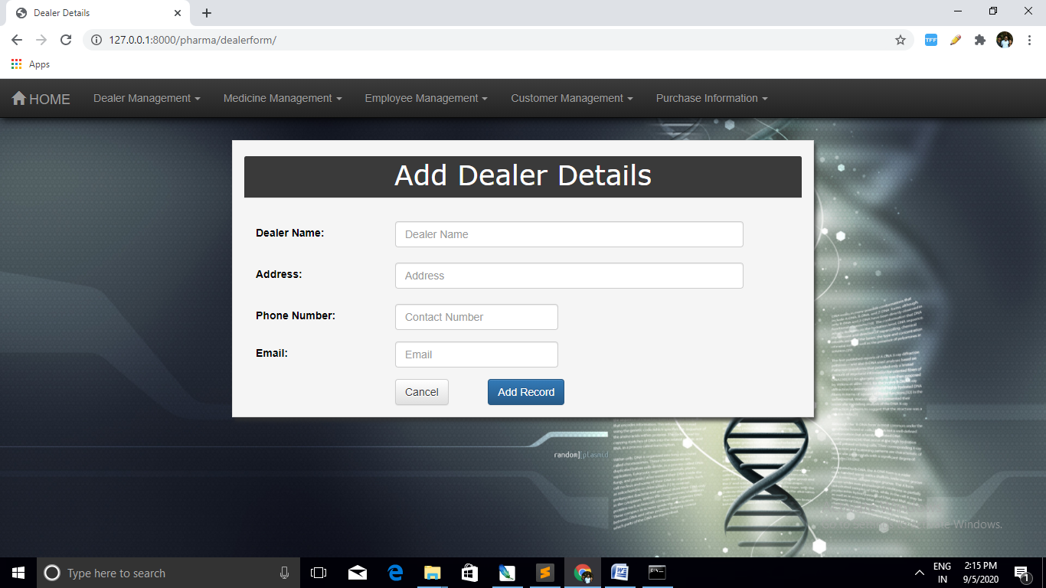

**Medicine Detalis**

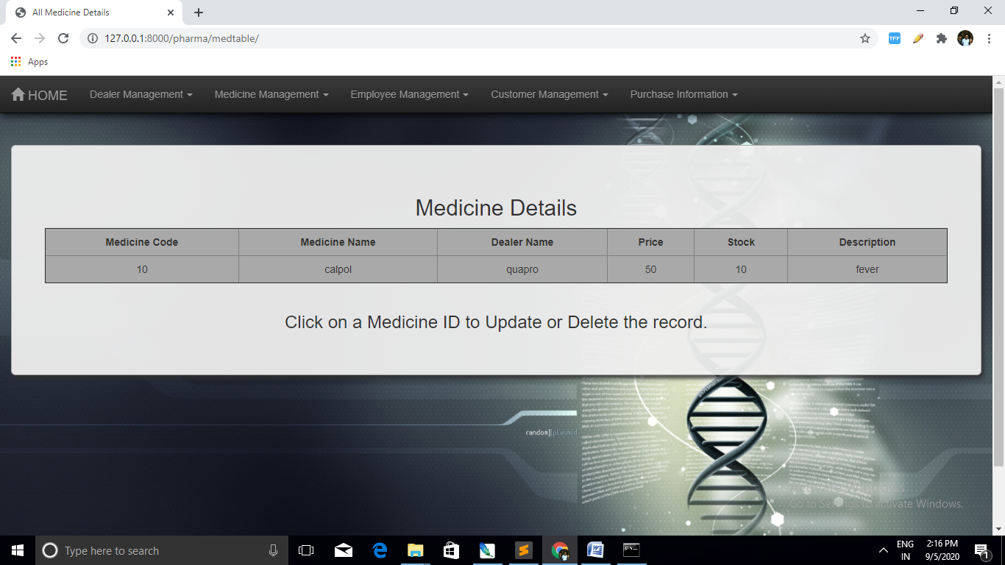

**Update Medicine Details**Medicine Detai

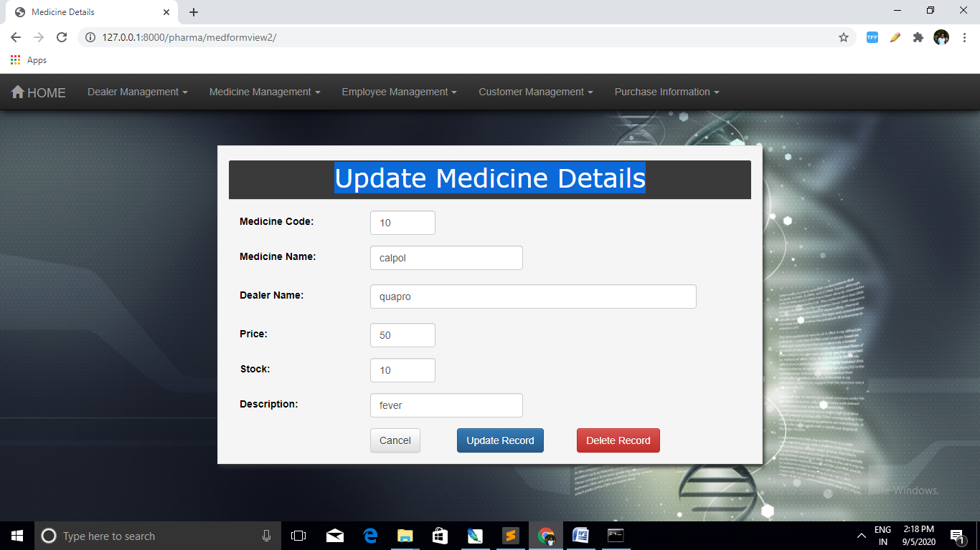

**ADD Employee Details**

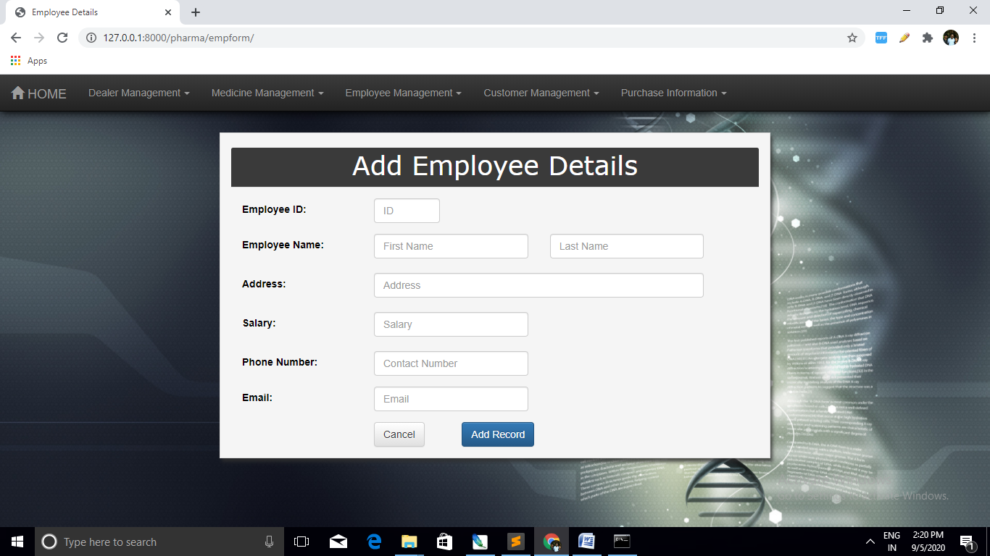

**EMPLOYEE DETAILS**

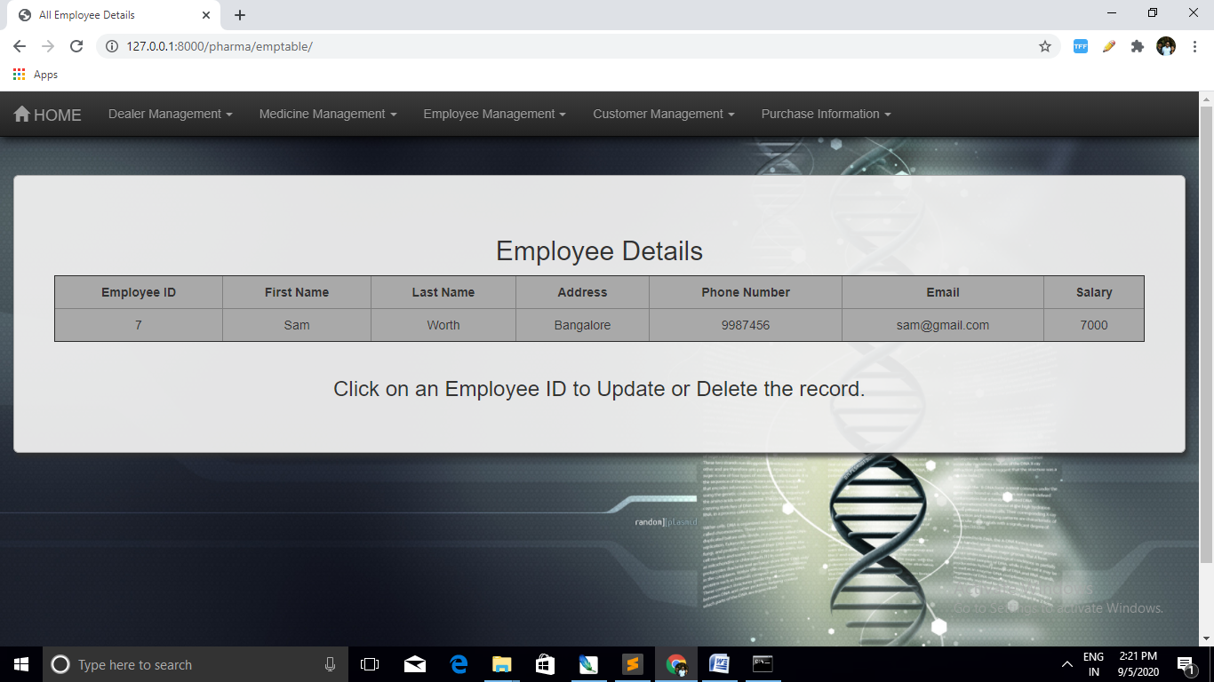

**Update Employee Details**

